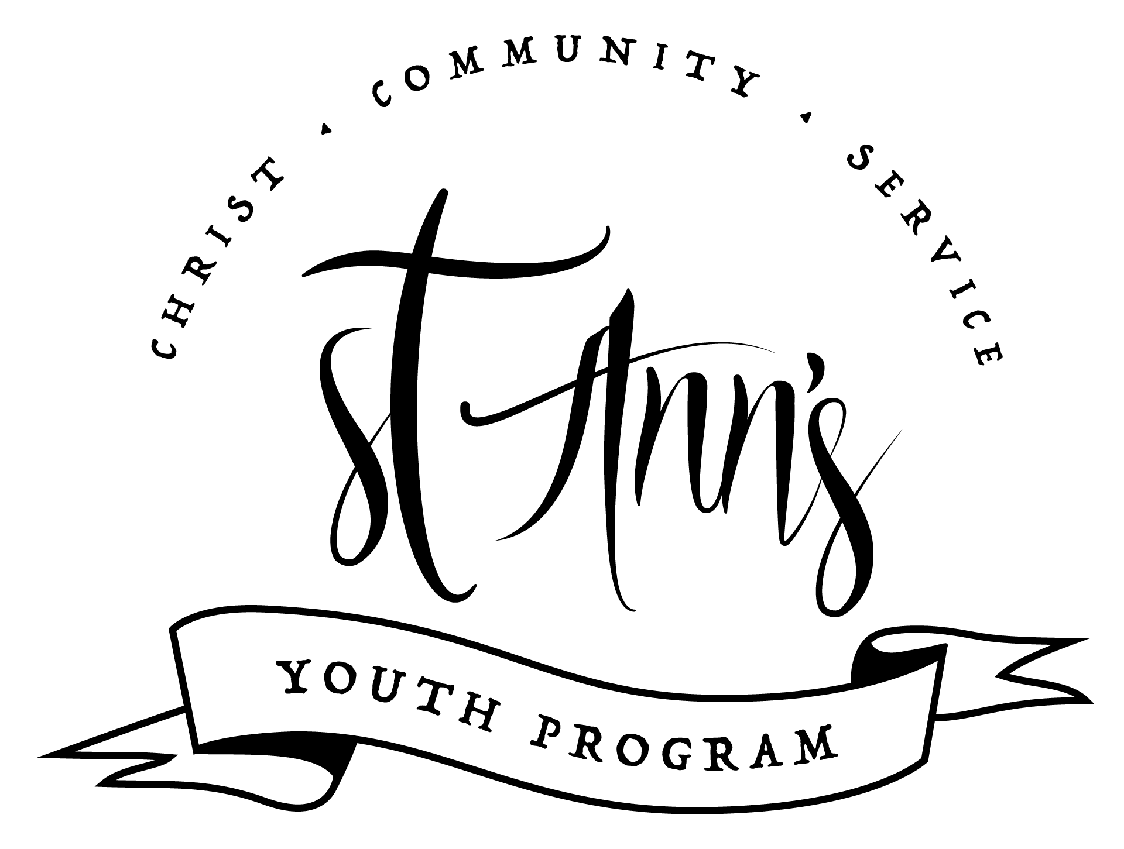
St. Ann DC Youth Program
Permission Form
Program Year 2023-2024

Parent/Guardian Contact Information

Names:

Emergency Contact - Phone Number:

Email(s) (for Newsletter):

Youth Information
Name | Grade | School | Dietary Restrictions
St. Ann DC Youth Program
Permission Form
Program Year 2023-2024

I ,
(printed name)
the undersigned, hereby give permission for my child(children) listed above to participate in St. Ann Catholic Church’s Youth Program for the academic year 2023-2024.

I understand that this Program may include online as well as in-person events.

I give my permission for their presence at the Program and for photos to be taken (no identifying information will be shared) with this signed form, and will not hold St. Ann Catholic Church legally responsible in the case of injury or harm.

Signature:

Program Contact Information
Kevin Reber, Youth Minister
Email: youth@stanndc.org
Phone: (732) 600-3520

St. Ann Catholic Church
4001 Yuma St NW
Washington, DC 20016
Phone: (202) 966-6288
www.stanndc.org

Child Protection Notice
Volunteers who, in the course of their volunteer work at St. Ann, have contact or will have contact with children, must comply with the Archdiocese of Washington's Child Protection Policy. All prospective volunteers for such positions at St. Ann's are asked to download the Child Protection Policy Compliance Checklist for Volunteers from the Archdiocese of Washington to complete the process. Volunteers must comply with the Archdiocesan Policy before beginning their volunteer ministry with children.

